**FINAL ACCEPTENCE DOCUMENT**

Please review the design and provide us your acceptance on the final screens.

**Opening Screen**:

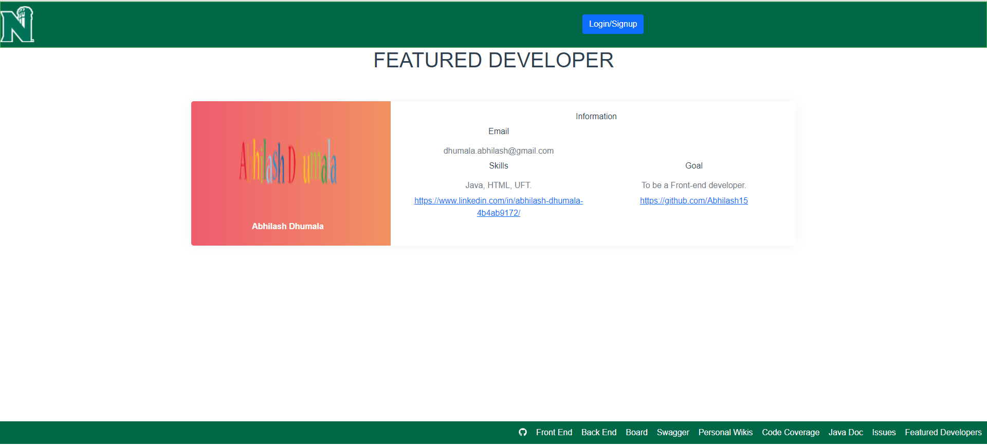

**Auth0 Login:**

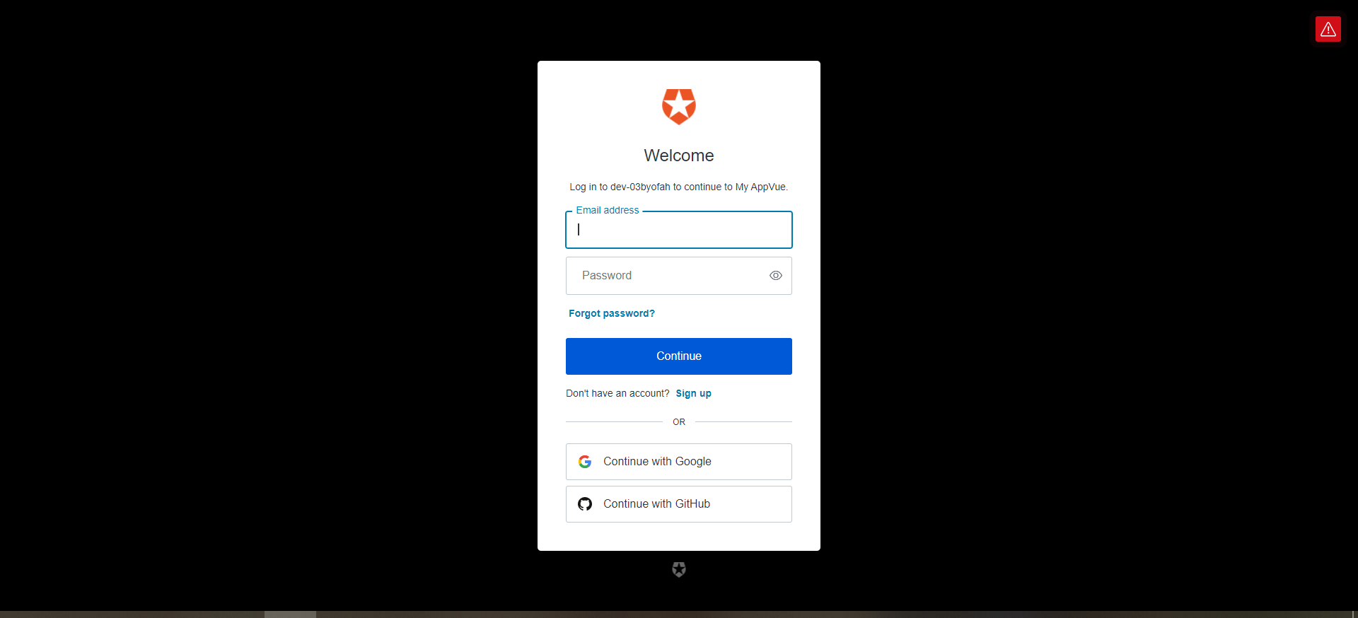

**After Login:**

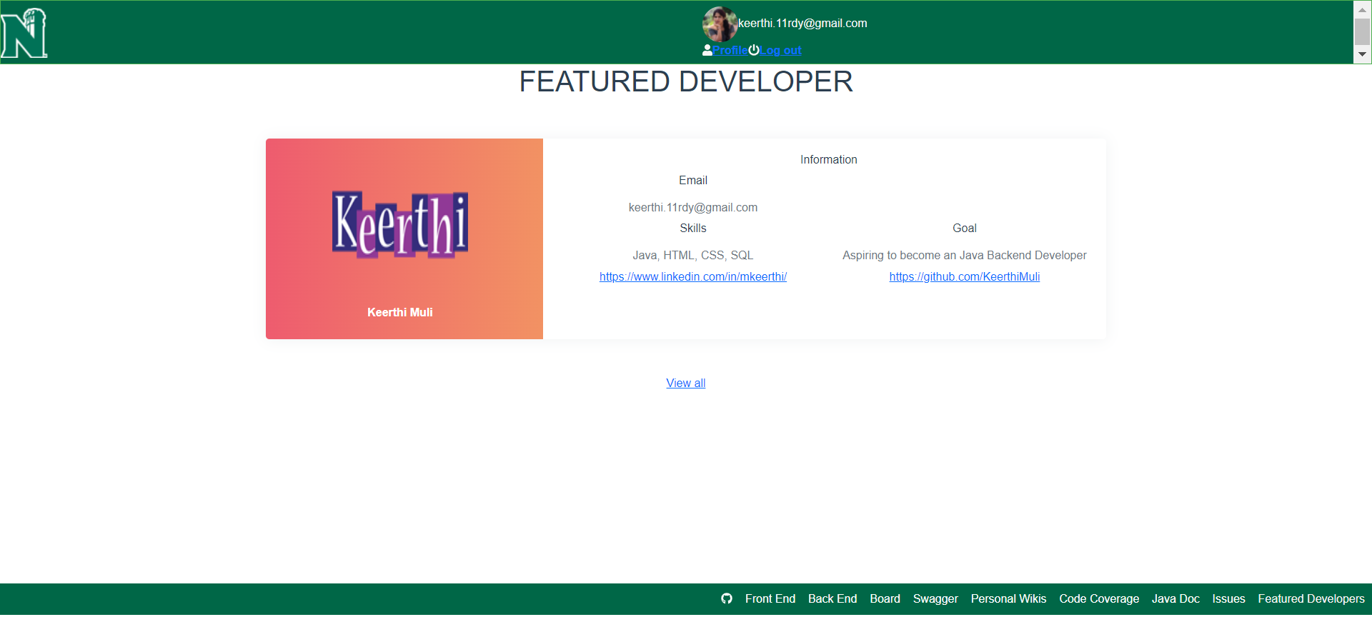

**ViewAll Screen:**

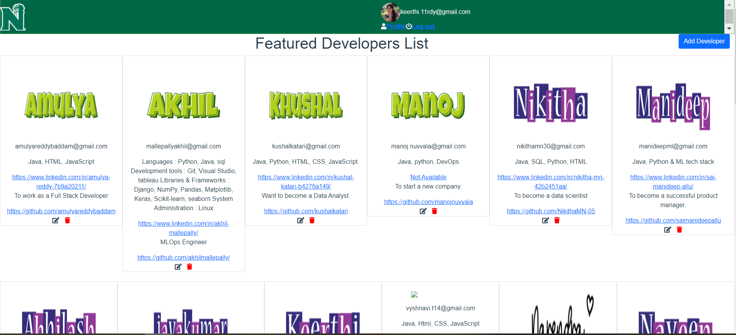

**Create Developer Screen**:

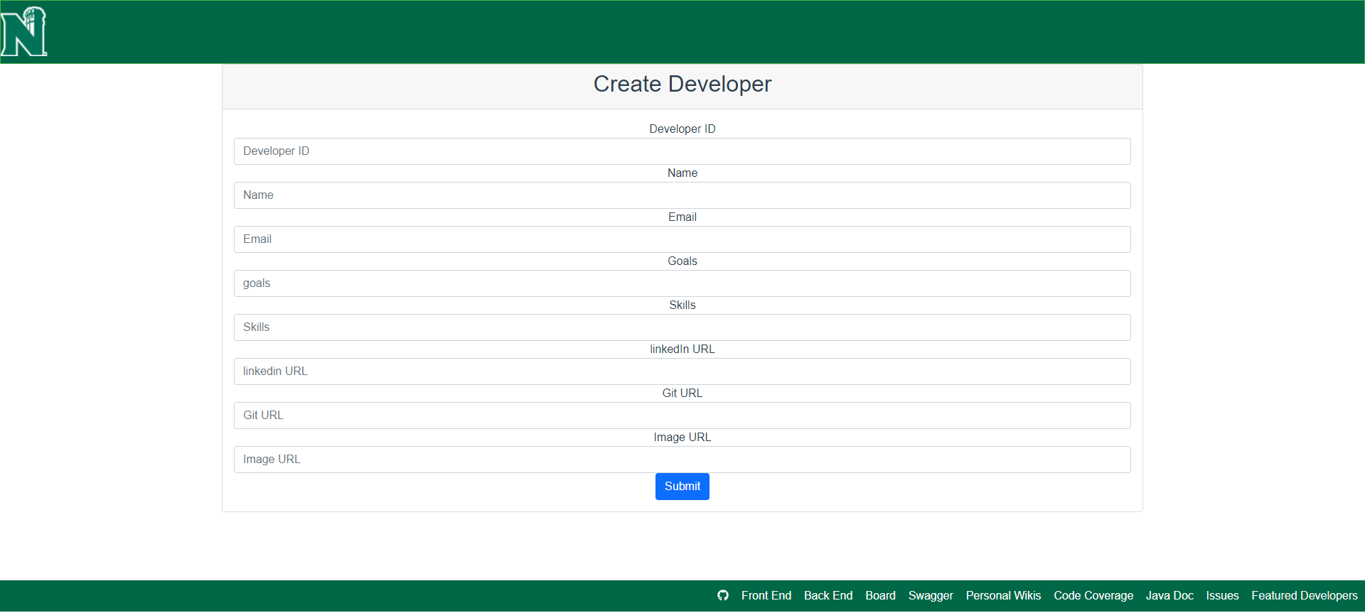

**Edit Developer Screen**:

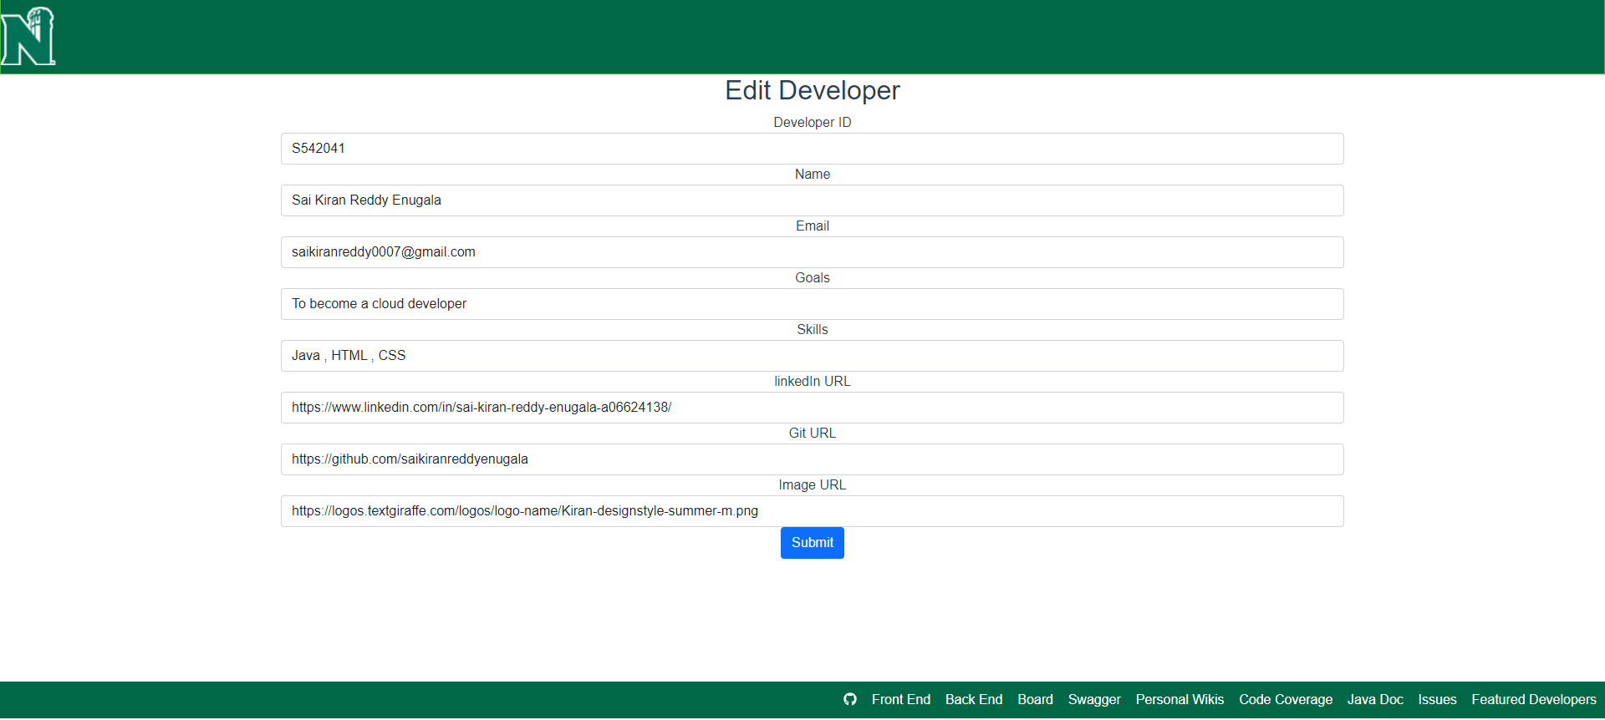

An commit done by client indicates the approval of the design.

**Proposal has been Approved by** (Kushal Satya Durgaji Katari).